# Self-Advocacy Flow Template

Use this template to plan and prepare to self-advocate.

Start at ‘Identify’ and work your way through to ‘Express’.

**Identify** 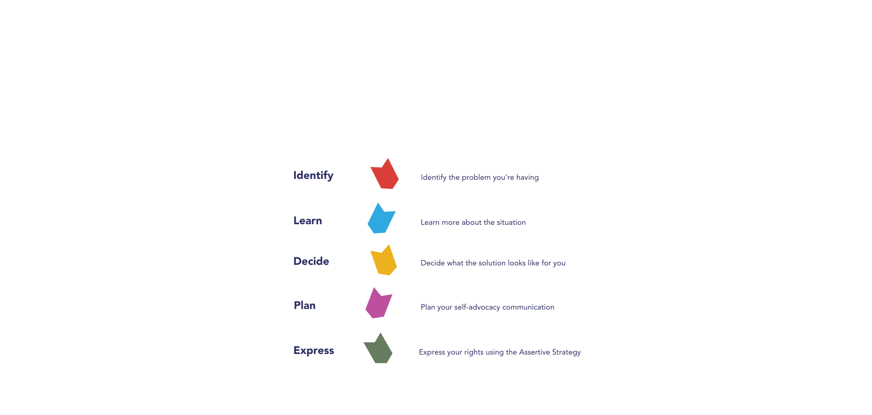Identify the problem you're having

|  |
| --- |
| **What would you like to change or achieve?** |

**Learn**  Learn more about the situation

|  |
| --- |
| **What are your rights?** |

**Decide**  Decide what the solution looks like for you

|  |
| --- |
| **When will you self-advocate? Who to?** |

**Plan** Plan what you will communicate

## Assertive Strategy

1. Communicate how you feel

|  |
| --- |
| **I feel…** |

2. Describe the issue/assert your rights

|  |
| --- |
| **Because…** |

3. Explain your solution

|  |
| --- |
| **I want…** |

**Express**  Express your rights – communicate to self-advocate

# Next steps

If the issue is not resolved the first time you ‘express your rights’, you may need to go back to previous steps to reconsider what you want to achieve, learn more or decide who else you could self-advocate to. You may also like to get some help from someone you trust to support you whilst you go through the flow again.

If the issue is still not resolved, you may need to seek support from a third party, such as the [Health and Disability Services Complaints Office (HaDSCO)](https://www.hadsco.wa.gov.au/) who resolve complaints regarding health, disability and mental health services.